* **Install Power BI Desktop and share the final screenshot of the report view page which appears when power desktop starts.**

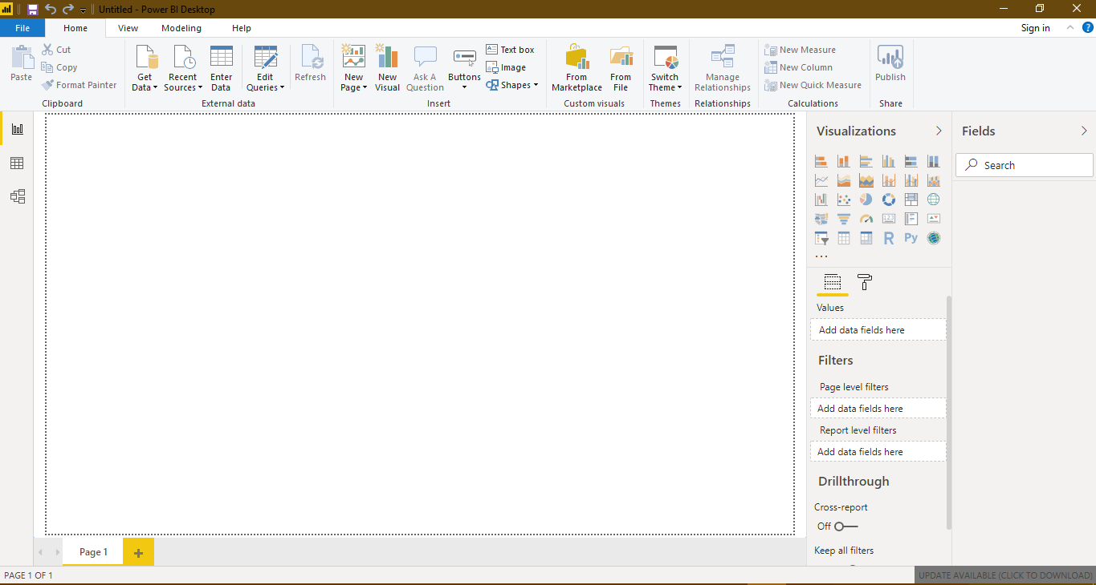

• Prepare a document and with the following screenshot

− Report View

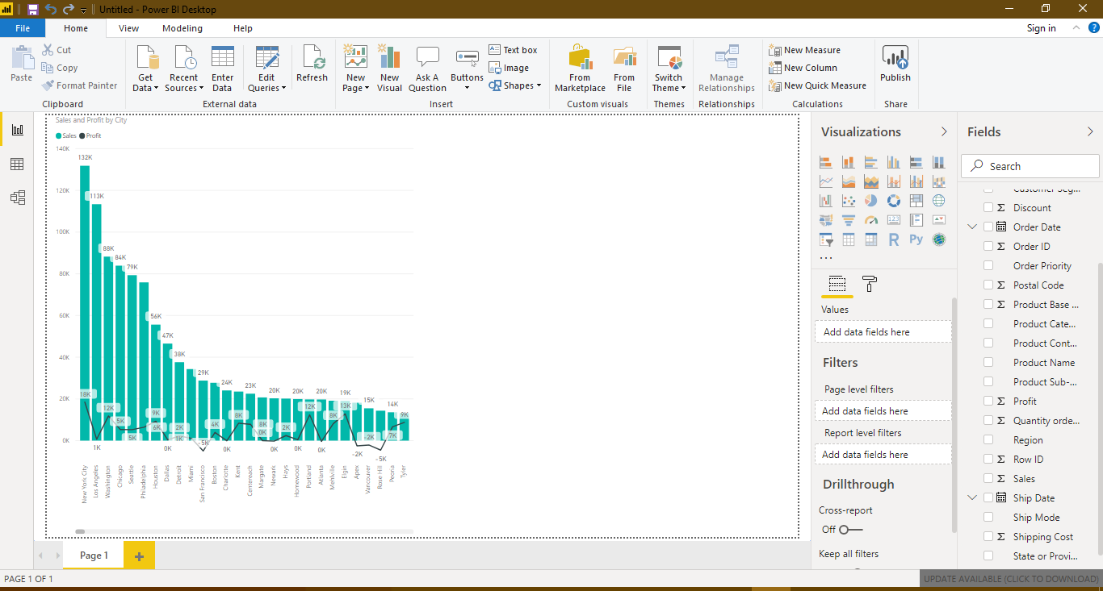

− Data View

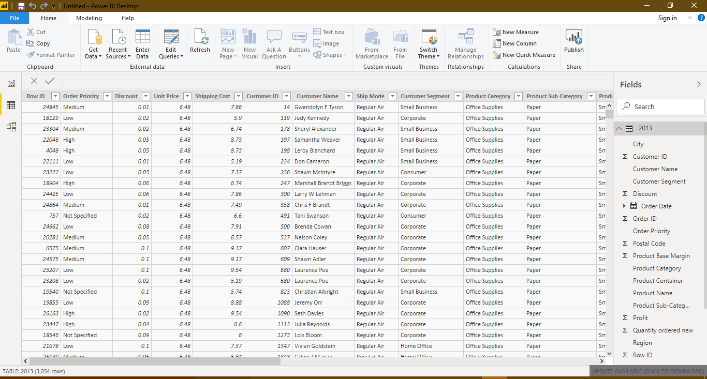

− Model View

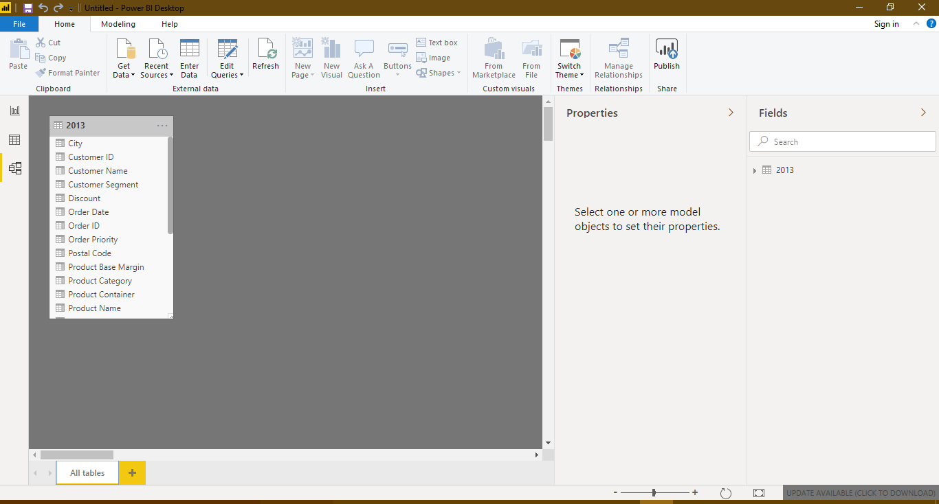

− Power Query Editor

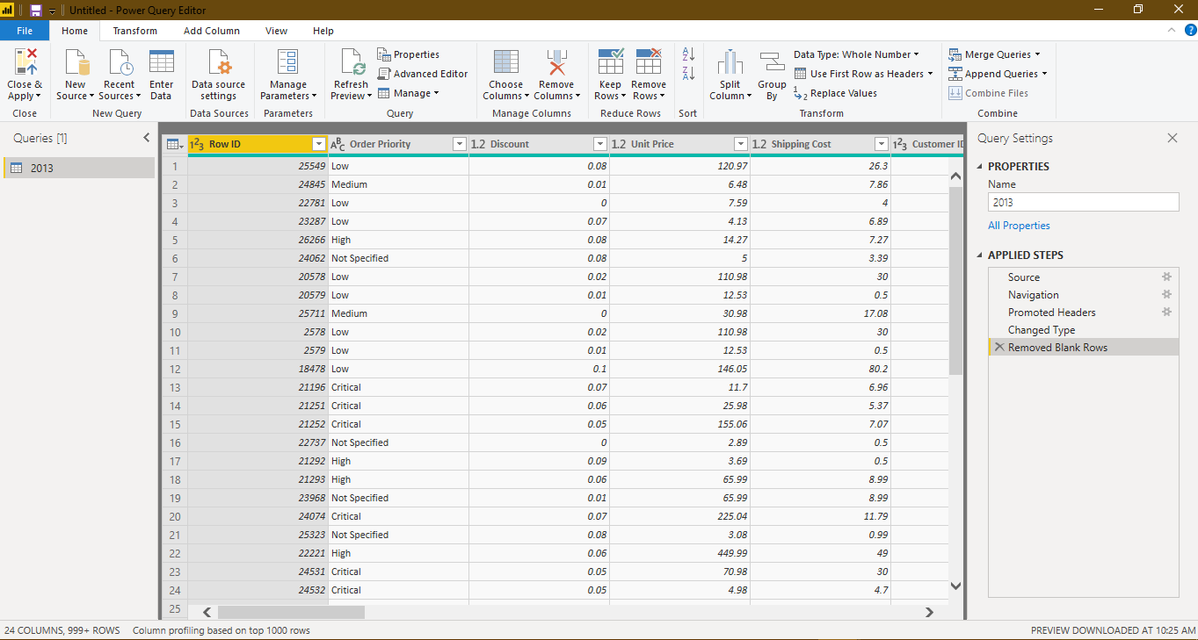

− Advance Editor

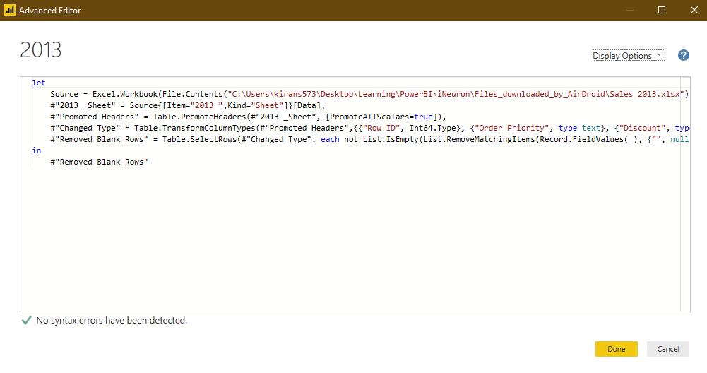

Prepare a document with details of the following along with their price

− Power BI Desktop

− Power BI Pro

− Power BI Premium

PowerBI Desktop - Free

